Instructions for
My Unity
Physician Order Entry

Table of Contents

Provider Steps 2
1. Find Resident 2
2. Go to the clinical tab 3
3. Go to the orders tab 3
4. Add Medication 4
5. Complete or Discontinue Medication Orders 14
Special notes 15

Nursing Steps 15
1. Go to “Orders Admin Mgmt” 15
2. Go to the new order(s) 16
3. Review the Order 17
4. Activate the Order 19

My Unity: https://visionhmhs.netsmartcloud.com/

Provider Steps

1. Find Resident
Click: Find Resident

Begin typing name in Quick Search box

Double click the name of the desired resident or highlight and click “OK”

Double click the appropriate admission date or highlight and click “OK”
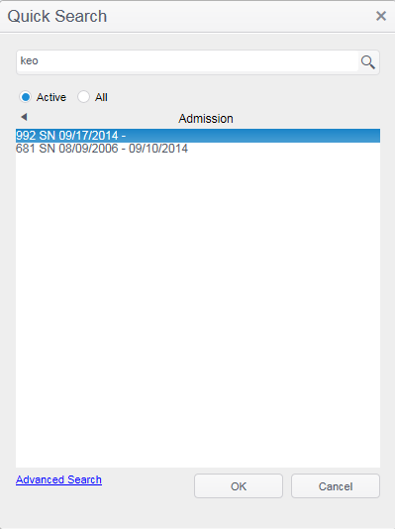

2. Go to the clinical tab
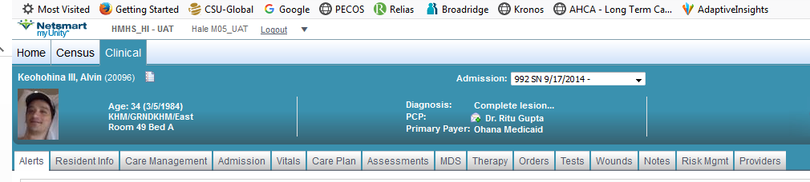

3. Go to the orders tab

4. Add Medication

Click the “Add Medication” hyperlink
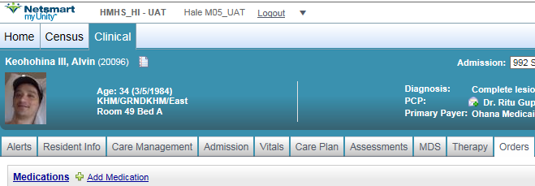
Search for medication by typing the name into the dialogue box
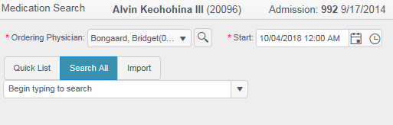
Select the appropriate item by clicking on the name

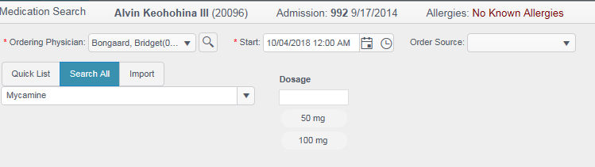
  - Ordering Physician: Verify the Ordering Physician is accurate (if not, click the down arrow next to the name and select proper physician)
  - Start: Verify the Start Date and Time (if not accurate, click the calendar icon or the clock icon to select the correct date and/or time).
  - Dosage: Click the appropriate dosage amount (this will trigger a new set of options)
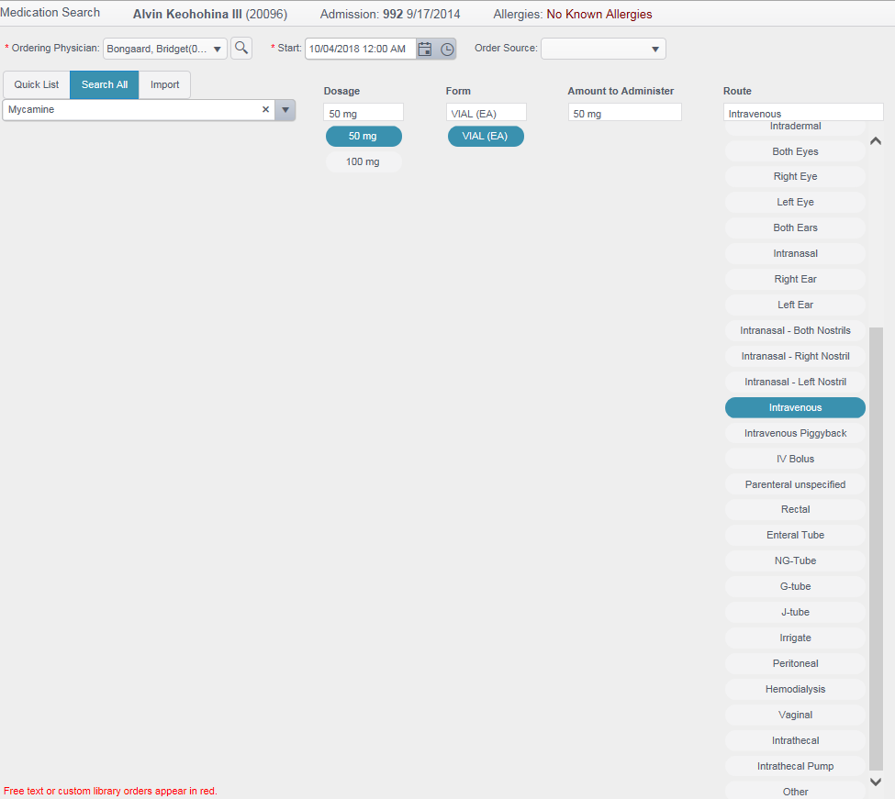
- Form: Select the “form” (if there are options)
- Amount: Enter amount to administer (should be in multiples of “dosage” amount)
- Route: select the rout to administer (i.e., oral, intravenous, J-tube, etc…)

  - Order Source: Click the drop down arrow and select “Telephone” (always)
Review information
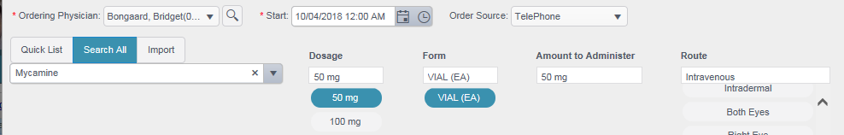

Click “Next”

Add Frequency/Duration
- Frequency: Click the drop down arrow and select the desired frequency
- Duration: After frequency is selected, the appropriate parameters for duration options will be displayed, enter the proper duration.
Examples of Duration Options:
  - Duration: Specific
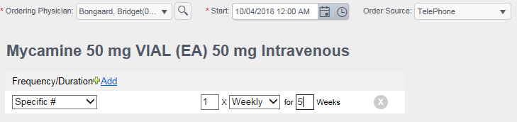

  - Duration: Every
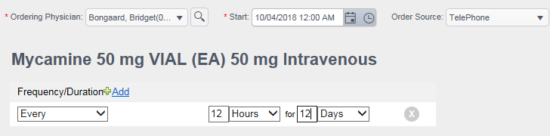
  - Duration: PRN
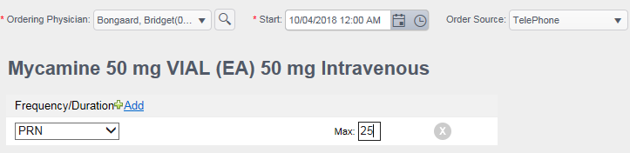
Click “Next”
The medication listing will show with the new order showing as “completed”. This must be changed to “DRAFT”.
- Enter Related Diagnosis(es)
  - Click the Related Diagnosis hyperlink (“Select”)
  - Select the diagnosis under in the drop down box under “PRIMARY”
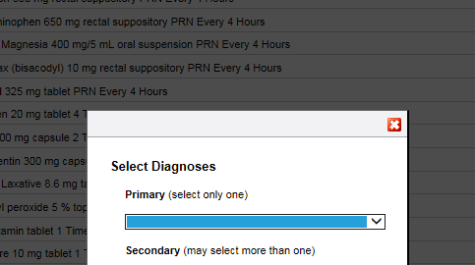

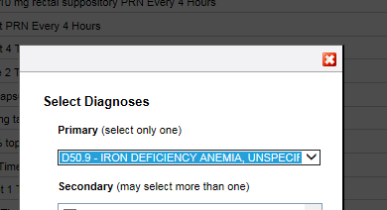

  - If there is a secondary diagnosis, use the check boxes to indicate the secondary diagnosis
  - Click “OK” when done

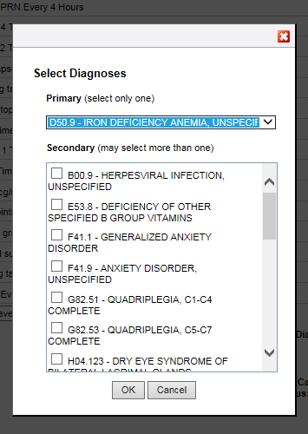

- Enter Physical Monitors
  - Click the Physical Monitors hyperlink (“Select”)
  - Check all that apply, scroll down to the bottom and click the “Save” button
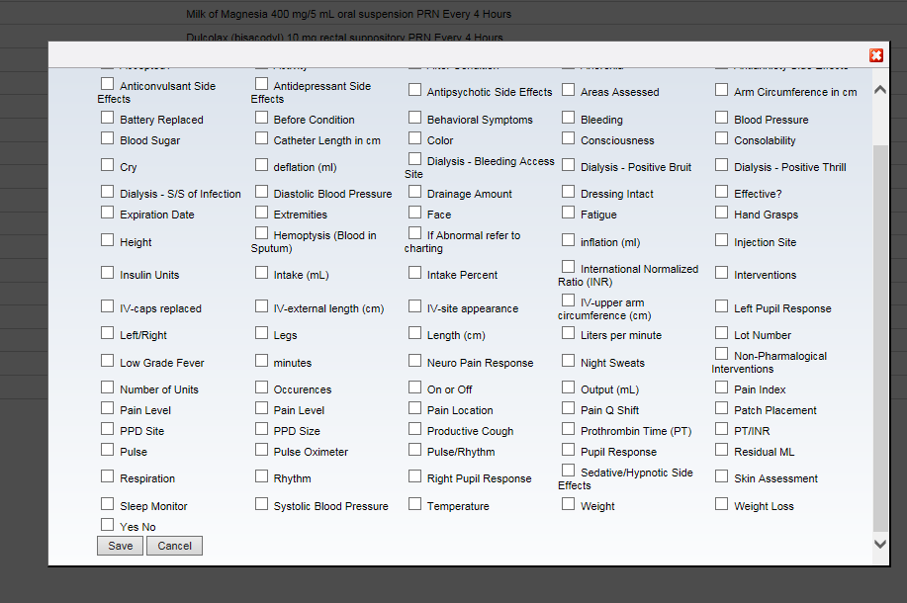

- Verify Related Diagnosis and Physical Monitors were entered
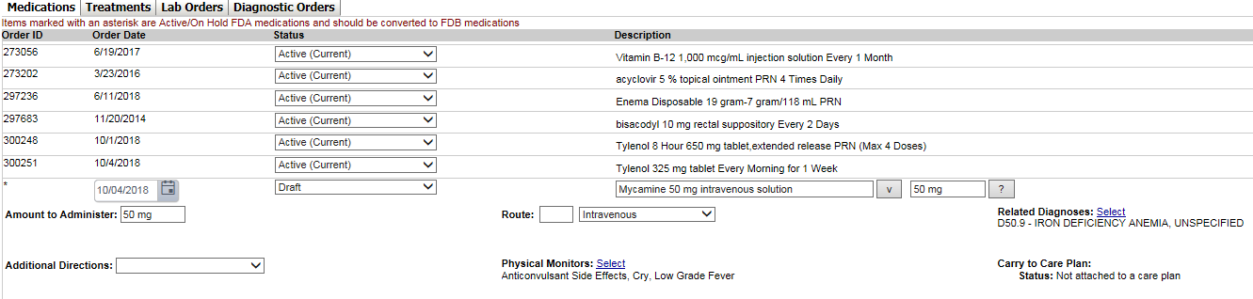

- Enter any Provider Notes in the notes box, verify order source is “Telephone” and ensure Provider name is accurate
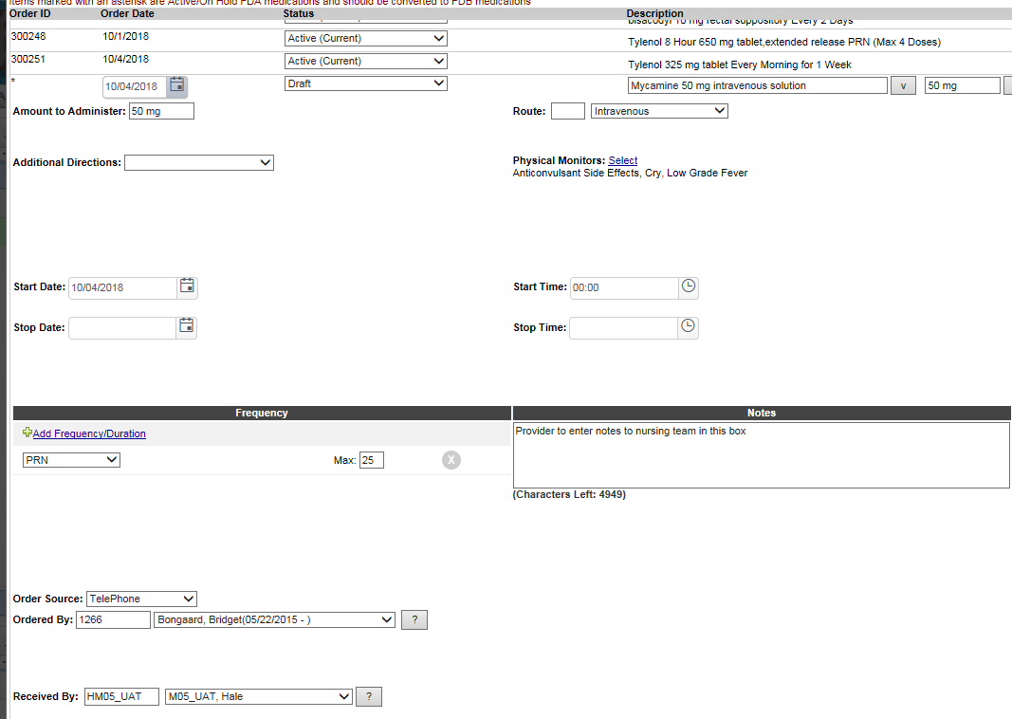

- Scroll down to the bottom of the screen and click “Submit”
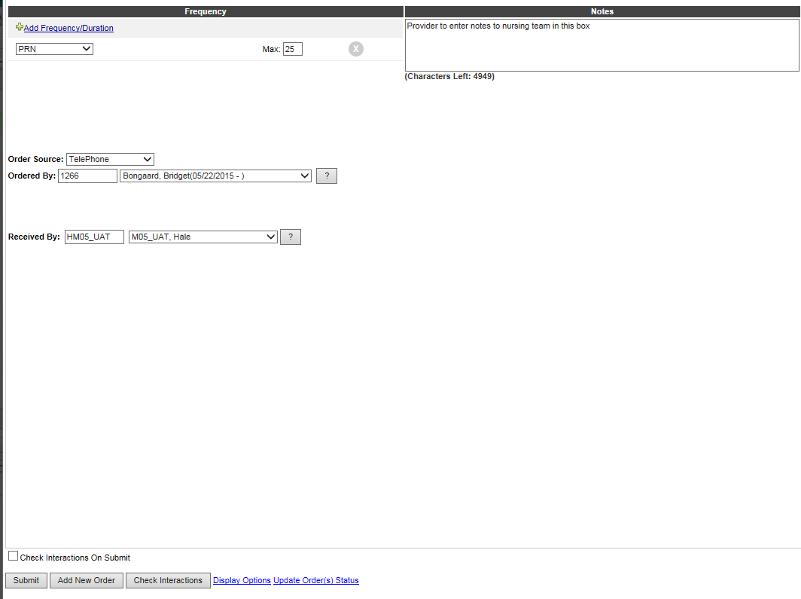
- Ensure order saves
- Review medication listing and ensure status shows as “DRAFT”
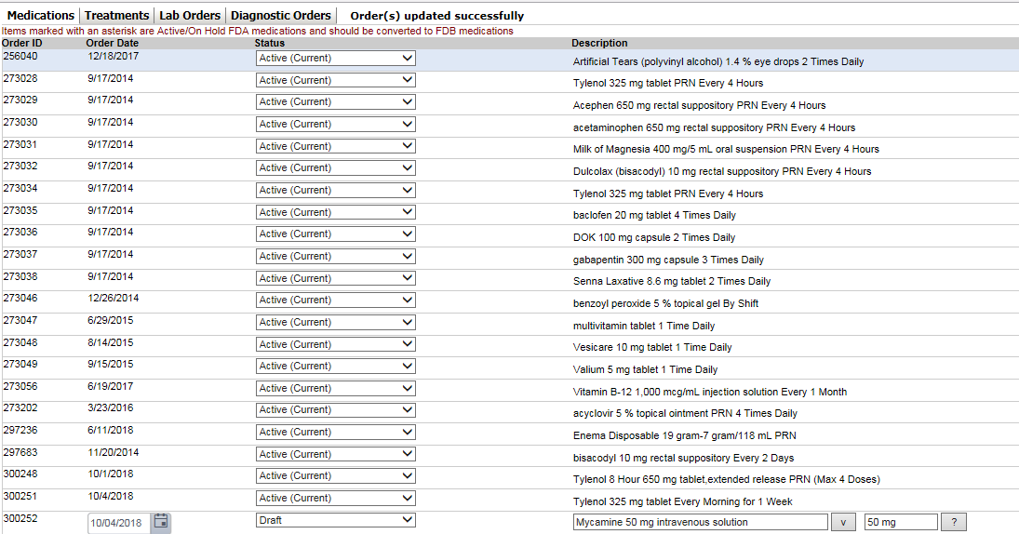

5. Complete or Discontinue Medication Orders
On the medications listing, click the down arrow under status and switch to “Completed” or “Discontinued” (note: Deleted can only be used if the order was never activated). Scroll down and click the “Submit” button. Once complete, or DC, the order will fall off of the list.

Special notes

When the provider clicks submit and the system it does not save but instead shows something in “red”, this error must be addressed and corrected and then click submit again before the order will be saved and entered into the medical record.

Nursing Steps

1. Go to “Orders Admin Mgmt”

On the left hand side of the screen, under “orders”, click the hyperlink “Orders Admin Mgmt”

2. Go to the new order(s)

In the “new orders” column, click the resident with the yellow alert notification (“dot”).

3. Review the Order

The medication listing for the patient will show the order in draft form.
Click on the order to review and read provider notes.

4. Activate the Order

Change the order from Draft to Active, scroll down and click “Submit”
Change to “Active (Current)”

Review the pending order and click submit again.
