***Linked Orders in EPIC:*** Linked orders functionality allows orders that are logically or clinically related to be placed in such a way that they are linked within the Epic system. There are 3 types of linked orders: ***1. “AND” 2. “OR” 3. “FOLLOWED BY”.*** When linked orders are modified, re-ordered, or discontinued these orders are grouped together so the user making the change is prompted that it is part of a linked order. For example, if one drug of a linked order is discontinued, the system will notify the user it is linked to another order so a decision can be made by the physician on what should be done. Soon, this functionality will be used in our order sets to help improve patient safety, clinician workflows, and eliminate unnecessary medication warnings since linking orders prevents duplicate therapy warnings from occurring. Below are some examples of linked orders and how they will appear in EPIC once we start using them.

***1.“AND” ORDERS:***  These orders occur together and are part of the same treatment regimen. Common uses include: Replacing a combination medication with 2 separate medications linked together. *(e.g. a combined order for losartan 50mg AND HCTZ 25mg).*

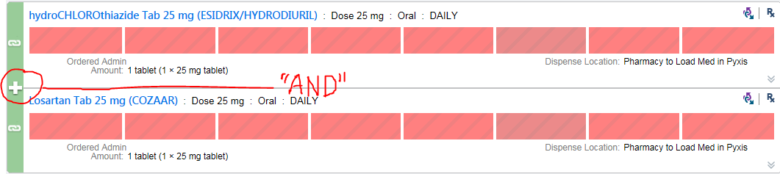

***2. “OR” ORDERS:*** Allows orders to be linked so as to indicate that only one order from the group should be acted upon at any given time. Common uses include: IV or PO panels *(e.g. ondansetron 4mg oral “OR” IV).* Medications can only be given once during the given frequency period when orders are linked this way. e.g. once the IV route is given, the oral route cannot be given for that time period and vice versa.

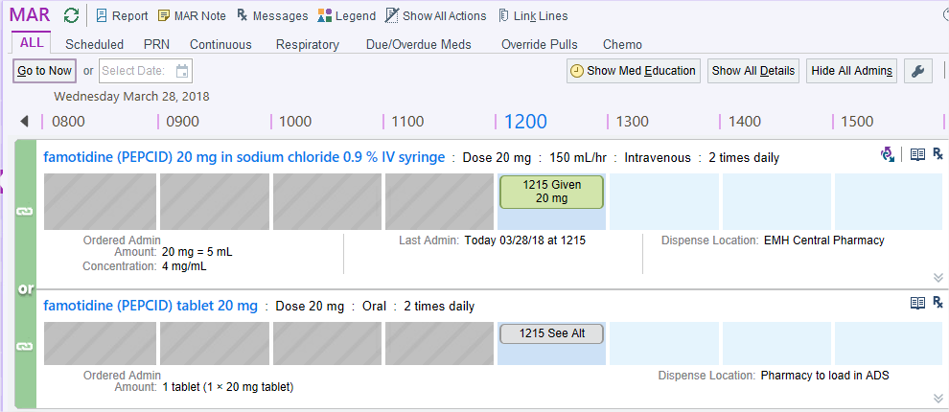

***3. “FOLLOWED BY” ORDERS:*** These orders are intended to occur in sequence (e.g. Taper orders).

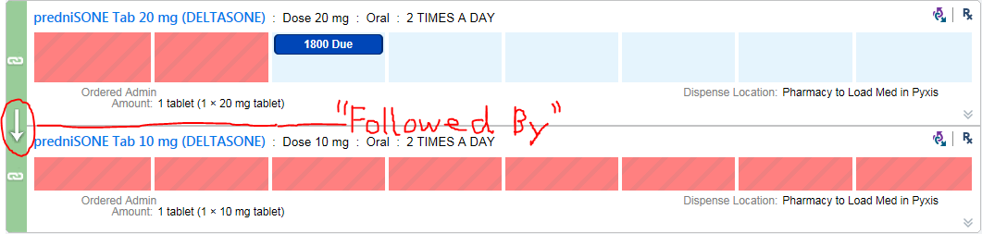

May I help you?



**DRUG SHORTAGES**

**IV HYDROMORPHONE**

**IV MORPHINE**

**IV FENTANYL**

**IV Potassium Chloride**

**TPN**

**DOBUTAMINE**

**LIDOCAINE 1g/250ml**

**Calcium Gluconate IV**

**Magnesium Sulfate IV**

**KCentra**

**FLUORESCEIN strips**

**For more information**

**contact:**

www.ashp.org/DrugShortages