***Insulin, a High-Risk Medication:***

Insulin is considered a high-alert medication because it is often associated with significant patient harm when used in error. According to a 2014 survey of pharmacists and nurses conducted by the Institute for Safe Medication Practices (ISMP), IV insulin ranked first and subcutaneous insulin ranked ninth among nearly 40 drugs and drug classes identified as high-alert medications that concerned practitioners. To help prevent medication errors and improve patient safety at MHS, a few changes have been made in our electronic medical build for insulin products.

As of June 28th, all IV bolus insulin regular orders will be drawn up by pharmacy and delivered to the nursing units for patients when ordered by physicians. Previously, the whole regular insulin vial was dispensed for each patient even though a single dose of IV bolus insulin was ordered. This was not ideal. Regular IV bolus insulin is used for DKA (Diabetic ketoacidosis) before an insulin drip is started, and as treatment for hyperkalemia given along with Dextrose. Pharmacy preparation of the regular IV bolus dose will help prevent wastage, and decrease the chance of an incorrect insulin dose from being inadvertently given. Pharmacy will continue to dispense the full vial of regular insulin, insulin 70/30, insulin NPH, and lispro for all subcutaneous (SQ) insulin doses. Nurses will draw these SQ doses up and administer to patients after a double check from another qualified healthcare provider is done as before. Pharmacy will continue to draw up individualized doses of Glargine (Lantus) for patients and dispense to the medical floors daily.

In addition, a new best practice alert (BPA) for insulin has been built and is now live in our EMR system. (See 1st screen shot below). This BPA alert will trigger when the nurse is charting (e.g. barcode scanning) the dose of any insulin product on the Medication Administration Record (MAR). It reminds the nurse to double check the insulin dose, route, frequency, and blood sugar with another qualified healthcare provider as outlined in MHS policy: 300-109-17 High Risk and High Alert Medications. When documenting the double check, please notate “verified with” and provide the name and title of the qualified healthcare provider in the comments section of the MAR. (See second screen shot).

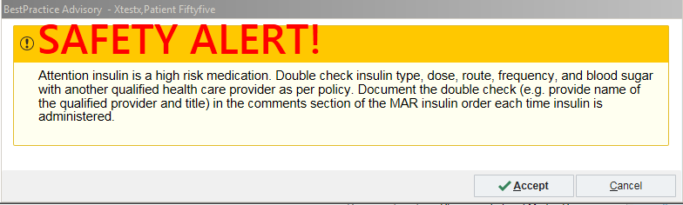

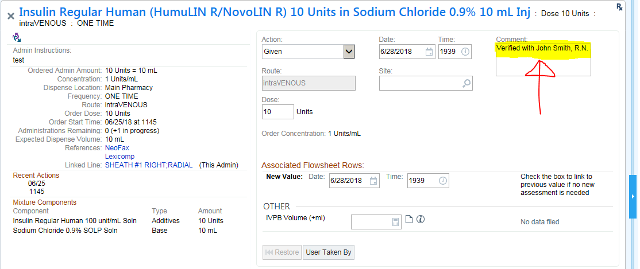

May I help you?



**DRUG SHORTAGES**

**IV HYDROMORPHONE**

**IV MORPHINE**

**IV FENTANYL**

**IV Potassium Chloride**

**TPN**

**DOBUTAMINE**

**LIDOCAINE 1g/250ml**

**Calcium Gluconate IV**

**Magnesium Sulfate IV**

**KCentra**

**FLUORESCEIN strips**

**Nalbuphine IV**

**Flumazenil IV**

**For more information**

**contact:**

www.ashp.org/DrugShortages