**Using Filters for IV Fat Emulsion:**

IV parenteral nutrition (e.g. Total parenteral or Peripheral parenteral nutrition) has always been filtered using a 0.2 micron air eliminating filter. This is done to help remove micro particulate matter that may potentially form when mixing electrolytes with TPN. Filtration also helps catch any microorganisms and prevents air from reaching the circulation. Intravenous fat emulsion has traditionally been administered below the 0.2 micron filter because infusing it through a 0.2 micron filter would clog and occlude it. The Institute of Safe Medication Practices has also advocated for the use of a 1.2 micron filter when administering IV lipid formulations to help prevent fat emboli and also for the same reasons mentioned above for filtering IV TPN. Many IV fat emulsion formulations now require the use of a 1.2 micron filter which can be found in the package labeling of each different lipid manufacturer. The current IV fat emulsion used at Maui Health Systems (20% Intralipids) should utilize a 1.2 micron filter.

Starting June 5th, 2018, nurses and health care providers will use a 1.2 micron filter at the end of the IV tubing when administering fat emulsion so we are in alignment with best practice standards. The EMR build for intralipids will contain the verbiage, “Use with 1.2 Micron filter” as a reminder for all healthcare providers. Pharmacy will also package the filter set together with the intralipid in the pyxis machines to help prevent confusion and accidental usage of the wrong filter. Please note the 0.2 micron filter should continue to be used with IV TPN as before. The 0.2 micron filter will continue to be stocked by Central Supply in pyxis supply machines. If IV fat emulsion is ordered, the 1.2 micron filter should be connected in line with the fat emulsion tubing. The IV fat emulsion (with filter) should then be administered via y-site below the 0.2 micron filter. Thus, in cases where patients are ordered for both IV TPN and fat emulsion, a total of 2 filters will need to be used. Please let all staff and colleagues know about this improvement for patient safety.

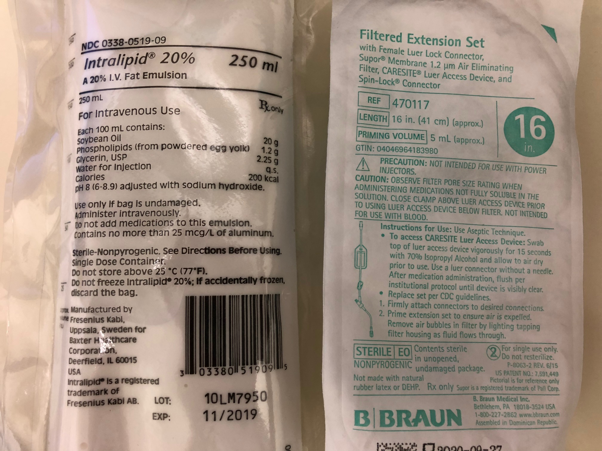

May I help you?



**DRUG SHORTAGES**

**IV Diltiazem**

**IV HYDROMORPHONE**

**IV MORPHINE**

**IV FENTANYL**

**IV Potassium Chloride**

**TPN**

**DOBUTAMINE**

**LIDOCAINE 1g/250ml**

**Lidocaine 1%**

**Calcium Gluconate IV**

**Magnesium Sulfate IV**

**KCentra**

**FLUORESCEIN strips**

**IV Fluconazole**

**NS, D5W 250ml**

**For more information**

**contact:**

www.ashp.org/DrugShortages