***Andexanet alfa (Andexxa):* Andexanet alfa (Andexxa) is a new direct oral anticoagulant (DOAC) reversal agent** approved by the FDA to counteract rivaroxaban and apixaban. It works by bindingdirectly tofactor Xa inhibitors and inhibiting activity of these anticoagulants. In addition, andexanet alfa inhibits the activity of the Tissue Factor Pathway Inhibitor (TFPI), increasing tissue factor-initiated thrombin generation. Availability of this drug is extremely limited. Only hospitals that participated in the andexanetstudies can obtain it currently. Broader availability is expected after early 2019. FDA approval was based on quick reversal of clotting time in patients taking [apixaban and rivaroxaban](https://hospital-pharmacist.therapeuticresearch.com/Content/Segments/PRL/2016/May/Comparison-of-Oral-Anticoagulants-9673). It is also being studied with other anticoagulants such as [betrixaban](https://hospital-pharmacist.therapeuticresearch.com/Content/Articles/PLH/2018/Mar/Don-t-Expect-the-New-Anticoagulant-Betrixaban-to-be-Added-to-Your-Formulary) (Bevyxxa), edoxaban (Savaysa), and enoxaparin. Preliminary data suggest andexanet alfa may limit progression of major bleeds associated with apixaban or rivaroxaban, but it is unclear if use in this setting improves patient mortality. It is also unknown whether it is superior to current treatments, such as 4-factor prothrombin complex concentrate (Kcentra). Current data show that around one in five patients who get andexanet alfa may develop thrombosis. In addition, the maximum dose can use up to 18 vials, take pharmacy about 45 minutes to prepare, and cost about $50,000.

Limited evidence indicates 4-factor PCC (*Kcentra*) may minimize the progression of major bleeds from apixaban or rivaroxaban. There aren't head-to-head studies, but 4-factor PCC success rates appear similar to the current evidence for Andexxa. Plus, 4-factor PCC can be prepared quickly at a lower cost ($13,000 for the max dose) compared to andexanet alfa.

Andexanet alfa will be directly compared to standard care in patients taking oral factor Xa inhibitors who present with an intracranial hemorrhage. Continued FDA approval will depend on these results which is expected by 2022.

***Sodium Bicarbonate Emergency Syringe Shortage:***

There is currently a new shortage of intravenous Sodium bicarbonate syringes and vials. The supply is limited due to manufacturing delays and production problems. Some supply is expected to return in December 2018, but there are no guarantees. MHS Pharmacy does have a limited supply of the Sodium bicarbonate vials, but there are few emergency syringes (Abbojects syringes) remaining. As such, crash carts will contain a “kit” with 3x sodium bicarbonate 8.4% 50ml vials along with 3x syringes for the nurse to draw up the sodium bicarbonate. Pharmacy will attempt to acquire as much supply of sodium bicarbonate as it becomes available. In the meantime, please conserve use of sodium bicarbonate whenever possible.

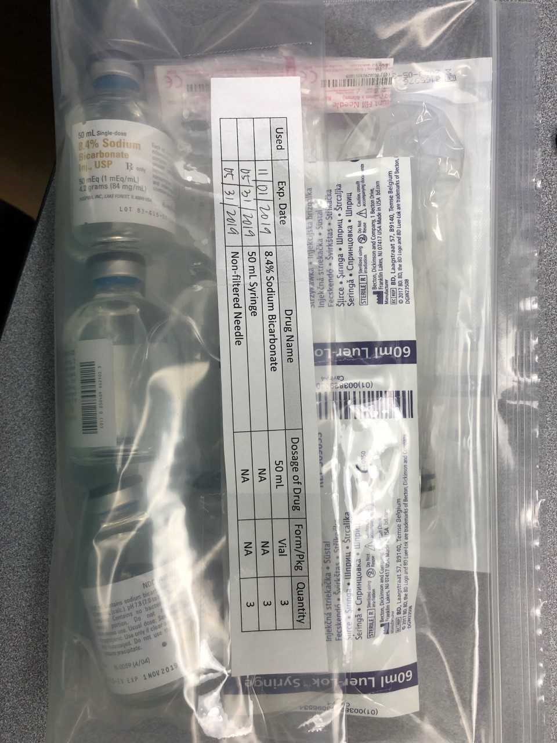

May I help you?



**DRUG SHORTAGES**

**IV HYDROMORPHONE**

**IV MORPHINE**

**IV FENTANYL**

**IV Hydralazine**

**DOBUTAMINE**

**Bupivacaine**

**AKWA tears**

**IV Labetalol**

**IV Sodium Bicarbonate**

**IV Sodium Phosphate**

**For more information**

**contact:**

www.ashp.org/DrugShortages