***Direct Oral Anticoagulant Panels in EMR:***

Panel orders have been built in the Health Connect preference lists at MHS to facilitate proper ordering of our direct oral anticoagulants (DOACs e.g. rivaroxaban and apixaban). Simply search for either DOAC and select the indication desired. Each specific order contains a pharmacy renal consult to ensure doses are adjusted appropriately for renal function and instructions for retiming the medication by pharmacy, so doses are conveniently administered. Rivaroxaban doses for treatment of atrial fibrillation and DVT/VTE treatment are timed with meals to maximize absorption and is a requirement for efficacy. The rivaroxaban and apixaban orders for DVT/VTE are built using the linked orders functionality so loading doses are given for the appropriate duration followed by the maintenance dose. E.g. Apixaban 10mg po q 12 hrs x 7 days followed by Apixaban 5mg po q 12 hrs. Rivaroxaban 15 mg po bid with meals x 21 days followed by Rivaroxaban 20 mg po daily with a meal. Pharmacy will renally adjust the dose.

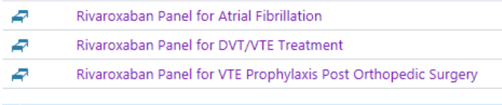



***NEW Beclomethasone inhaler (QVAR RediHaler):***

The traditional Beclomethasone (QVAR) HFA inhaler for asthma is being discontinued. The manufacturer has remarketed the product as Beclomethasone QVAR RediHaler which is a breath actuated inhaler. Like before, the new inhaler is available in the same strengths (40mcg/actuation and 80mcg/actuation) and after each use patients should rinse their mouths to prevent thrush. To administer appropriately:

Always hold inhaler upright when administering. The white cap must be closed to prepare the inhaler before each inhalation or patient will not receive medication. Do not open cap until patient is ready to take medication. Once ready, open white cap, have patient breathe out fully, place mouthpiece in mouth, close lips around mouthpiece and inhale deeply to release medication. Remove inhaler, hold breath for 5-10 seconds, then breathe out slowly. If more than 1 puff is needed per dose, make sure the cap is closed first, then repeat steps above. DO NOT USE WITH A SPACER. Rinse mouth after use!

This new inhaler **SHOULD NOT BE USED WITH A SPACER** as it will prevent effective delivery of the medication. Unfortunately, this has implications for the pediatric population as the QVAR RediHaler is indicated only for children at least 4 years of age. If a steroid inhaler is needed in younger children (<4 years), please consider use of another steroid inhaler like fluticasone (Flovent) HFA which can be used with a spacer to ensure appropriate delivery of medication.

May I help you?



**DRUG SHORTAGES**

**IV HYDROMORPHONE**

**IV MORPHINE**

**IV FENTANYL**

**IV Potassium Chloride**

**Flumazenil**

**IV Promethazine**

**IV Hydralazine**

**DOBUTAMINE**

**LIDOCAINE- all injectable**

**forms**

**Calcium Gluconate IV**

**Magnesium Sulfate IV**

**KCentra**

**FLUORESCEIN strips**

**IV Ondansetron**

**Bupivacaine**

**AKWA tears**

**For more information**

**contact:**

www.ashp.org/DrugShortages